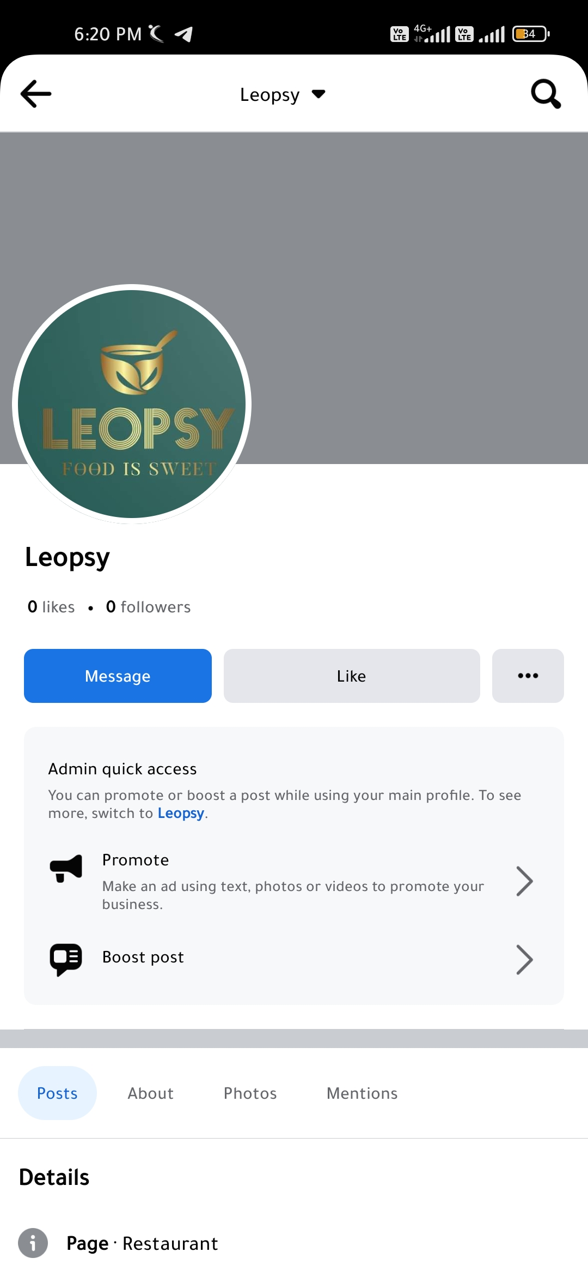**ASSIGNMENT-2**

Create a New Facebook Business Page and Post one social media poster for your brand.

|  |  |
| --- | --- |
| NAME | Deepak.S |
| NM ID | 8BBEA82F38B820380CA46C34FD4FACB2 |
| ASSIGNMENT 2 | Create a New Facebook Business Page and Post one social media poster for your brand |

